Consequences of Consumerism

Goal |  | 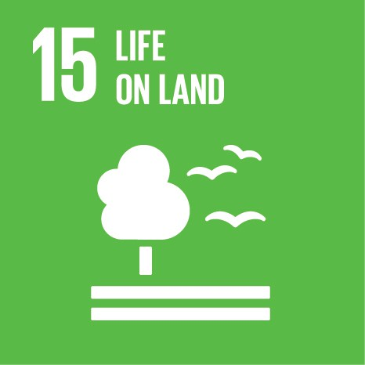
Overview |  | The intention with this activity is to make the students reflect upon the importance of nature, how irresponsible consumption is destroying the earth, the consequences of its destruction and what small changes can do to change the pattern of overconsumption.
Age group |  | 13-21
Group size |  | Up to 28
Time |  | A 45 minute lesson + homework tasks (before and after class)
Subject(s) |  | Science  Humanities  Languages
Objectives | Behavioural competences | - To make conscious choices regarding personal consumption considering the production chain of the items purchased  - To take personal actions to protect life on land (forests, lakes, flora and fauna)
 | Reflections | - To reflect upon the effects of deforestation  - To reflect upon the importance of nature  - To reflect upon the responsibility for the future generations  - To reflect upon the consequences of consumerism
 | Lifelong learning key competences | - Mathematical competence and basic competences in science and technology  - Sense of initiative and entrepreneurship  - Social and civic competencies
Materials |  | Projector to show the video clips  Videos:  Conservation International, “Nature Is Speaking – Kevin Spacey is The Rainforest,” https://www.youtube.com/watch?v=jBqMJzv4Cs8  Joe Smith, “How to Use a Paper Towel,” https://www.ted.com/talks/joe_smith_how_to_use_a_paper_towel
Preparation |  | Homework task to the students:  - Read the two texts (below) and make a list of minimum 10 things that you can do to change your consumption habits (e.g. save paper, recycle, save electricity).  Literature:  - Joe Myers, “It’s only August – and we’ve already used up all of this year’s natural resources,” World Economic Forum, 9 August 2016, https://www.weforum.org/agenda/2016/08/it-s-only-august-and-we-ve-already-used-up-all-of-this-year-s-resources/?utm_content=buffer78fcf&utm_medium=social&utm_source=facebook.com&utm_campaign=buffer  - United Nations, “Life on Land: Why it Matters,” http://www.un.org/sustainabledevelopment/wp-content/uploads/2016/08/15_Why-it-Matters_Goal15__Life-on-Land_3p.pdf
Instructions |  | Ask the students what they have written on their lists over how changes in their consumption habits. Write all the examples on the blackboard and discuss their ideas.  Discuss the two texts that the students have read at home. What did the students reflect upon in the texts? What is meant by Earth Overshoot Day? What will the consequences be for the future generations if we continue to use resources faster than the earth can replenish them?  Play the video clip “Nature Is Speaking – Kevin Spacey is The Rainforest” to the students.  - Discuss the video clip. What is its message? What are the students’ immediate impressions of its message?  - Why is nature important?  - Why are forests important?  - Discuss the costs of achieving sustainable forest management against the costs of not correcting the problem (see the homework text from the United Nations)  Play the video clip “How to Use a Paper Towel” to the students.  - Discuss the video clip. What is its message? What are the students’ immediate impressions of its message?  - What is the impact of overconsumption on the environment?  - Besides reducing the use of paper, what can individuals do to reduce the world’s ecological debt? (homework article from World Economic Forum)  - What can be done on individual, political and sector levels to make production and consumption more sustainable? (e.g. avoiding certain products, limit food waste, making policies, planting threes)
Evaluation |  | Homework task:  Essay on how consumerism impacts the environment. Let the students do research on the topic and tell them to reflect on consumerism’s impact on the nature, and how to limit these impacts. They can use the articles below for inspiration.
Follow up suggestions |  | Ask students to keep diary over a week where make entries everyday showing how in that day they have reduced their personal consumerism. Follow-up with students in a week. Discuss what changes the students can make on a long-term basis to reduce their consumerism.
Ideas for actions |  | - Find a place in your neighbourhood where the students can help planting trees  - Recycle waste in the school  - Ask students to plan and conduct in the school a one-day campaign on reducing consumerism
Further information |  | The Sustainable Development Goal 15 (Life on land) targets: http://globalresponsibility.eu/goal-15-life-on-land/  United Nations, “Goal 15: Sustainably manage forests, combat desertification, halt and reverse land degradation, halt biodiversity loss,”  http://www.un.org/sustainabledevelopment/biodiversity/  United Nations, “The Future We Want,” United Nations Conference on Sustainable Development, 2012, https://sustainabledevelopment.un.org/content/documents/733FutureWeWant.pdf  PBL Netherlands Environmental Assessment Agency, “How sectors can contribute to sustainable use and conservation of biodiversity,” CBD Technical Series No 79, 2014, https://sustainabledevelopment.un.org/content/documents/1981cbd-ts-79-en.pdf  Mathy Stanislaus, “Resource efficiency: lessons from Henry Ford on doing more with less,” World Economic Forum, 2016, https://www.weforum.org/agenda/2016/03/resource-efficiency-henry-ford-manufacturing/

