Child Labour in the Chocolate Industry

Goal |  | 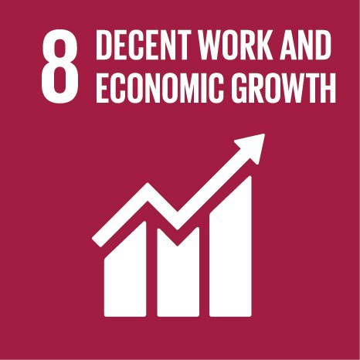
Overview |  | In this activity the students learn about the social, economic and environmental costs of the production of chocolate.  The students learn about the cocoa production’s impact on the environment and on the use of child labour and trafficking.  - Child labour  - Eradication of the worst forms of child labour
Age group |  | 13-21
Group size |  | Up to 28
Time |  | Three 45 minute lessons
Subject(s) |  | Humanities
Objectives | Behavioural competences | - To consume more sustainably with consideration to fair trade
 | Reflections | - To reflect how personal consumption and life-style affects someone on the other side of the world  - To reflect upon labour rights and child labour  - To reflect upon the production environment of the products we consume
 | Lifelong learning key competences | - Sense of initiative and entrepreneurship  - Social and civic competencies  - Mathematical competence and basic competences in science and technology
Materials |  | Access to video cameras (can be the students’ smartphones)  Computer with an editing program
Preparation |  | Familiarise yourself with the issue of child labour and the prevalence in the cocoa and chocolate industry in West Africa.
Instructions |  | First and Second Class:  Introduce the topic child labour  Emphasise that children have the right to get an education and to leisure, but that in some countries these rights are frequently violated. Cocoa farmers in West Africa often have a low income which means that they are not able to pay their workers a sufficient salary. Therefore, children have to work in cocoa farms to help provide for their families. If the work is harming children’s health, is dangerous, or keeps the children from getting an education it is considered abusive and unacceptable by the international community.  Make a movie:  Divide the students into groups of 4-8. Let them make a movie on child labour in the cocoa industry. The movie should present facts about child labour and about the chocolate production. Tell them that the movie should be presenting the human and ecological costs of the using child labour in the chocolate production (dangerous work, bad for the health, keeping children out of school) and also present possible solutions to the eradication of child labour.  Make the students find literature and statistics. They can use some of the literature that is listed under “further information” and find their own sources.  They can film it with video cameras, or if they have smart phones, they can use them. After filming, let the students edit the video clips on a computer to make them into one movie.
Evaluation |  | Third Class:  Show the movies in the class. After watching all of the movies, discuss the issues and solutions that were brought up.
Follow up suggestions |  | As an alternative to making movies, the students can write an essay or make group presentations on the topic, reflecting on the impacts of child labour and the production’s impacts on the environment.  Show the students the documentary The Dark Side of Chocolate by Miki Mistrati and U. Robin Romano, Made in Copenhagen (2012)  http://www.emu.dk/modul/lyssky-chokolade-film#  Child labour also remains a problem in Europe:  Council of Europe, Child labour in Europe: a persisting challenge,” 2013, http://www.coe.int/it/web/commissioner/-/child-labour-in-europe-a-persisting-challen-1
Ideas for actions |  | - Look for the fair trade labels when you buy chocolate
Further information |  | The Sustainable Development Goal 8 (Decent Work and Economic Growth) targets:  http://globalresponsibility.eu/goal-8-decent-work-economic-growth/  Office of the United Nations High Commissioner for Human Rights, “Convention on the Rights of the Child,” 1989, http://www.ohchr.org/EN/ProfessionalInterest/Pages/CRC.aspx  Make Chocolate Fair! Campaign, ”Human Rights and Child Labour,” https://makechocolatefair.org/issues/human-rights-and-child-labour  International Cocoa Initiative: http://www.cocoainitiative.org/en/  Global Chocolate and Cocoa Industry, “Working Towards the Elimination of the Worst Forms of Child Labour in West African Cocoa Farming Communities,” http://i2.cdn.turner.com/cnn/2011/images/04/06/response.pdf  International Labor Organization, “Africa: Child Labor in Cocoa Fields/ Harkin-Engel Protocol,” http://www.ilo.org/washington/areas/elimination-of-the-worst-forms-of-child-labor/WCMS_159486/lang--en/index.htm  UNICEF data and resources on child labour:  http://data.unicef.org/child-protection/child-labour.html
Print outs

Make Chocolate Fair! Campaign, ”Human Rights and Child Labour,” https://makechocolatefair.org/issues/human-rights-and-child-labour

